**Product Offerings**

The various credit mechanisms offered under TAP are:

(a) Supporting Trade Finance Instruments - Stand-by Letters of Credit (SBLCs), Confirmation/advising of Trade Finance Instruments

(b) Irrevocable Reimbursement Undertaking

(c) Fronting of Guarantees - Arranging fronting/advising of guarantees (Bid Bond, Performance, Advance Payment, Retention Money Guarantees) for export and import.

(d) Risk Participation (funded and non-funded)

(e) Credit Lines

**Structures:**

1. Supporting Trade Finance Instruments

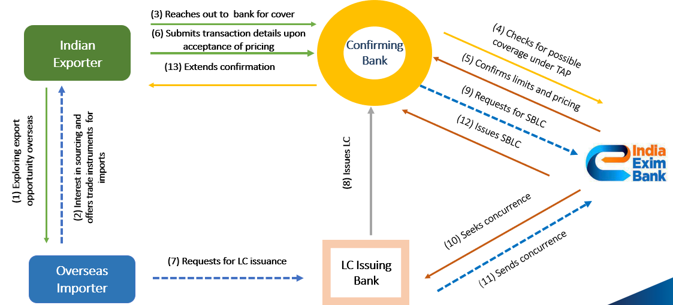

1. Irrevocable Reimbursement Undertaking

1. Fronting of Guarantees

1. Risk Participation

1. Credit Lines - India Exim Bank has been extending credit lines to overseas financial institutions who act as intermediaries and on-lend to overseas buyers for import of equipment, goods and services from India.

|  |  |
| --- | --- |
| **Borrower** | **XYZ Bank** |
| **Facility Amount** | USD -------- mn |
| **Currency** | USD |
| **Purpose** | To support India related eligible transactions covering export of goods, services, and projects from India. |
| **End use confirmation** | End use confirmation along with quarterly declarations in the prescribed format signed by an authorised signatory/ statutory auditors will be required confirming that India Exim Bank’s facility has been utilised to support transactions covering export of goods, services, and projects from India. |
| **Availability Period** | One month from the date of Facility agreement |
| **Security** | Unsecured |
| **Rate of Interest** | SOFR + ------ bps p.a. |
| **Upfront fee** | ------ |
| **Interest Period** | Quarterly |
| **Default Interest** | 1% p.a. |
| **Tenor/Maturity Date** | Depending upon the tenor of underlying India related eligible assets |
| **Repayment** | Structured / Bullet payment at the maturity |
| **Documentation** | * Facility agreement * Legal opinion * Disbursement request * Any other document as may be prescribed by the Sanctioning Authority |